

Kohat University of Science & Technology
Institute of Computing
Kohat, Khyber Pakhtunkhwa, Pakistan

BSCS / BSSE Final Year Project Proposal (FYP)

Intelligent Pharmacy Store Management System

Submitted By:

Sr.No | Registration No | Name | Class | Email
1 | CS120222110 | Talha Rehman | BSCS 7th B, Open | talhakhank51@gmail.com
2 | CS120222063 | Basit | BSCS 7th B, Open | Basit.ahmed.usman@gmail.com

Supervisor

Name: Zeeshan Iqbal
Designation: Assistant Professor
Institute/Department: Institute of Computing

Date Submitted: September 8, 2025

Supervisor Signature : ________________

Abstract

This project introduces an AI-powered Intelligent Pharmacy Store Management System with two primary interfaces:

Store Owner Module: Manage medicines, monitor stock, and track expiry dates with AI-powered demand prediction and stock alerts.

User Module: AI reads and explains prescriptions in simple language, suggests medicine alternatives, and provides health support through reminders, diet advice, and exercise recommendations.

Unlike traditional static systems, this solution integrates AI to act as a personal healthcare assistant, making medicine management smarter and healthcare guidance more accessible.

Introduction

Pharmacies frequently struggle with expired medicines, stock shortages, and difficulties explaining prescriptions to patients. Patients, in turn, face challenges understanding medical terms and lack affordable, continuous doctor support.

Our system addresses both sides:

For pharmacies → better stock management and reduced financial loss.

For patients → AI-driven tools to simplify prescriptions, suggest safe alternatives, and provide personalized health support.

This makes the system dynamic, intelligent, and practical.

Background/Literature

Current pharmacy management systems are limited to record-keeping of stock and sales. They lack intelligence and user support. Recent studies highlight the potential of Artificial Intelligence (AI), Natural Language Processing (NLP), and Machine Learning (ML) to:

Read and interpret prescriptions.

Predict medicine demand.

Provide personalized health notifications.

This project builds on those advancements by combining pharmacy management with AI-driven healthcare guidance.
References:
People/Projects Working on Similar Ideas:
MedAssist AI – An AI-based prescription reader and medicine reminder system.
PharmaEasy – Online pharmacy app providing medicine alternatives and delivery services.
PillPack by Amazon – Automated pharmacy management with dosage reminders.
Microsoft Healthcare NLP – Research on AI for medical document and prescription analysis.
AI Used in This Project:
Gemini API → For prescription understanding, medicine details, and alternative suggestions.

Proposed Solution

The system will consist of two integrated modules:

1. Store Owner Module

Add, update, and delete medicines.

Track stock levels and expiry dates.

AI-driven predictions for demand and stock alerts.

2. User Module with AI Integration

Upload prescription → AI reads and explains in simple language.

Suggests alternatives if medicine is unavailable.

Provides reminders for dosage, diet, and exercise.

Functions as a personal healthcare assistant, especially for patients who cannot afford frequent doctor visits.

Motivation

Patients often misuse medicines due to lack of understanding.

Missed doses and wrong intake are common issues.

Pharmacies face financial losses from expired stock.

Healthcare costs are unaffordable for many.

This project aims to bridge the gap by supporting both patients and pharmacies through AI integration.

Objectives

Build a pharmacy management system with AI integration.

Develop AI models to read and simplify prescriptions.

Provide AI-driven medicine alternatives and recommendations.

Implement smart reminders for dosage, diet, and exercise.

Predict stock needs and alert about expiring medicines.

Challenges

Collecting medical data for AI training.

Handling handwritten prescriptions with high accuracy.

Ensuring AI explanations remain simple but medically correct.

Maintaining privacy, security, and usability.

Methodology
Requirement Analysis: Identify needs of pharmacies and patients.
System Development: Build modules for store owners and users
AI Integration:
NLP → prescription reading and explanation.
ML → inventory prediction.
Personalized assistant → reminders and health suggestions.
Testing: Evaluate system usability, AI accuracy, and real-world performance

Tools and Techniques

Mobile App: Flutter

Frontend (Web): React.js, Tailwind CSS

Backend: Node.js, Express.js

Database: PostgreSQL / MongoDB

AI/ML: Python (TensorFlow, PyTorch, Scikit-learn), NLP (spaCy, Hugging Face)

Other: GitHub (version control), Postman (API testing)

Tentative Work Plan
The work plan of the project is given in Figure 3.

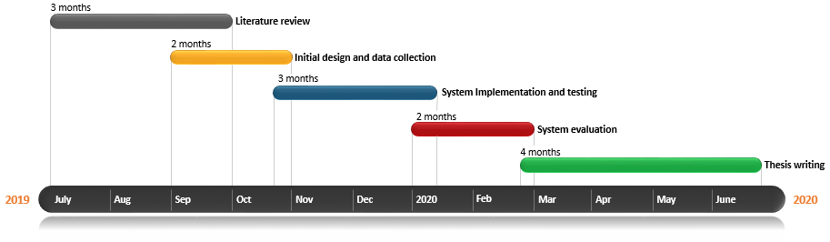
Figure 1: Work Plan

